 | RASTRICK HEALTH CENTRE NEWSLETTER | AUTUMN 2026

Welcome to Our Autumn Update
Thank you to all patients who attended our latest Patient Reference Group meeting on September 14th.
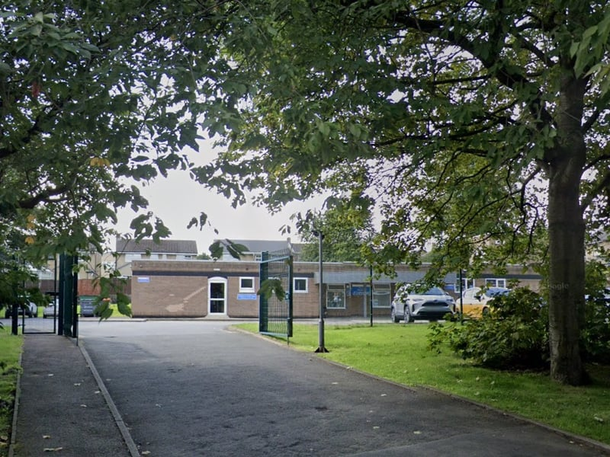

PRACTICE & STAFFING NEWS  - Practice Manager Retirement: We bid a fond farewell to Kate after 19 years of service and wish her well. Recruitment for a new manager is due to commence shortly.  - New Practice Nurse: Welcome to Adele, our new Practice Nurse. She replaces Jenny, who has successfully progressed to Trainee Advanced Clinical Practitioner.  - Training Practice: Our new GP Registrars have started at the beginning of August are settling in well.  WELLBEING GARDEN SUCCESS  Our garden upgrade has been a wonderful success, offering a quiet reflection space for staff and patients alike.  - Charity Support: The grand opening event successfully raised £250 for Overgate Hospice!  - Community Volunteers: We are looking to team up with local charities and volunteers to maintain the garden. Please let us know if you would be interested in helping. | SURGERY CAPACITY & ACCESS  With local housing expansion, our patient list continues to grow.  - Average appointment waiting times: Routine appointments within 7-10 days; Reserved urgent slots daily.  - New Telephone System: Being installed late September.  - System Connect: Replaced Patchs with a clear online web form for non-urgent queries (48hr response).  - Additional services: Direct referral to First Contact Physio, Clinical Pharmacists, PEARS Opticians, Pharmacy First being utilized appropriately.  - Winter Respiratory Hub: Acute winter appointments in Brighouse due to commence at the end of September.  FLU & COVID VACCINATION CLINICS  - Saturday Clinic: 3rd October (invites issued as stock arrives).  - Weekday Clinics: Available with Practice Nurses.
  JOIN THE PRG - NEXT MEETINGS
  Held quarterly at 6:30 PM:
  • Monday, 30th November 2026
  • Monday, 22nd February 2027
  • Monday, 24th May 2027

